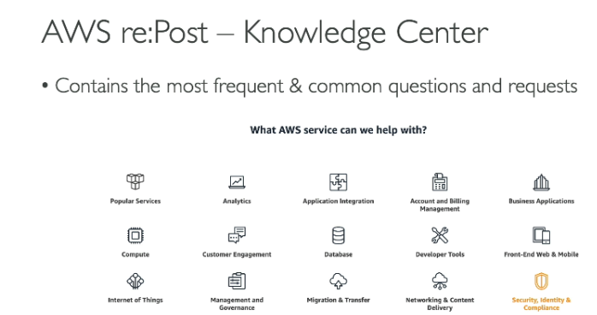

[**https://repost.aws/knowledge-center**](https://repost.aws/knowledge-center)